BTS{V-O4* 19-0340 Reg,No.
B.Tech. Degree IV Semester Examination April 2019
trTE 404 APPLIED THERMODYNAMTCS
Q}Ad ^{Scheme)}
Tirne: 3 ^{Hours} Maximurn Marks: 100
PART A
(Ansrv er ALL questions)
(a) State and explain Carnot theorem.
I.
(b) Explain the Claussius inequality.
(c) What do you understand by PVT surface?
(8*s-40)
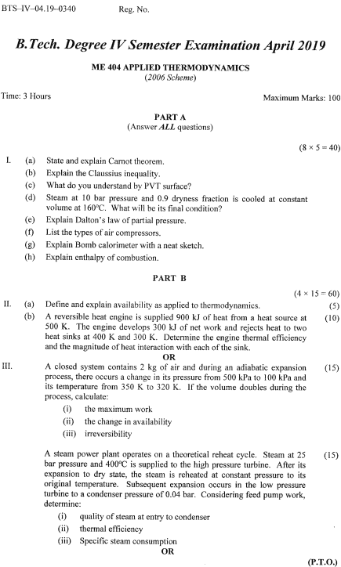
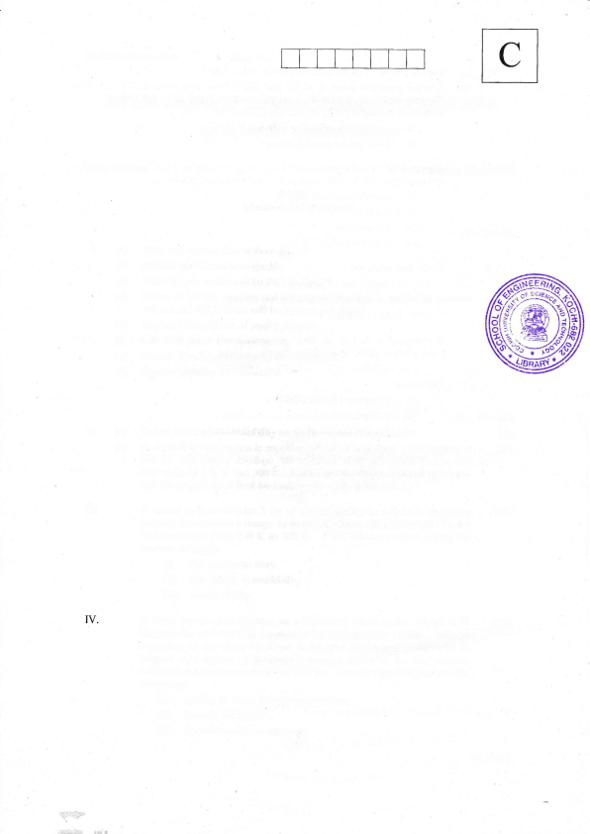
(d) Steam at 10 bar pressure and 0.9 dryness fraction is cooled at constant volume at 160'C. What will be its final condition?
(e) Explain Dalton's law of partial pressure.
(0 List the types of air compressors.
(g) Explain Bomb calorimeter with a neat sketch.
(h) Explain enthalpy of combustion.
PART B
₍₄ ^{x} 15:60)
(a) Define and explain availability as applied to thermodynamics. (5)
II.
(b) A reversible heat engine is supplied 900 kJ of heat from a heat source at (10) 500 K. The engine develops 300 kJ of net work and rejects heat to two heat sinks at 400 K and 300 K. Determine the engine thermal efficiency and the magnitude of heat interaction with each of the sink.
OR
ilI.
A closed system contains 2 kg of air and during an adiabatic expansion (15) process, there occurs a change in its pressure from 500 kPa to 100 kPa and its temperature from 350 K to 320 K. If the volume doubles during the process, calculate:
(i) the maximum work
(ii) the change in availability
(iiD irreversibility
A steam power plant operates on a thooretical reheat cycle, steam at 25 (15) bar pressure and 400oC is supplied to the high pressure turbine. After its expansion to dry state, the steam is reheated at constant pressure to its original temperature. Subseqrient expansion occurs in the low pressure turbine to a condenser pressure of 0.04 bar. Considering feed pump work, determine:
(i) quality ofsteam at entry to condenser
(ii) thermal eflioiency
(iii) Specific steam consumption
OR
(P.r.o.)
(a) Explain any one high pressure boiler with a neat sketch. ⁽⁵⁾ (b) A boiler generates steam at l0 bar and 200'c from feed water at 37oC. (10) The coal used in the furnace has a calorific value of 33965 kJ/kg and 10 kg ofsteam is generated perkg ofcoal burnt. Calculate:
(i) equivalent evaporation from and at 100oC
(ii) boiler power
A mixture of I kg of oxygen and 2 kg of nitrogen occupies 1.2 m3 volume (15) at temperature 300 K. Assuming perfect gas behaviour, determine:
(D specific volume
(ii) pressure
(iii) gas constant
(iv) molecular mass
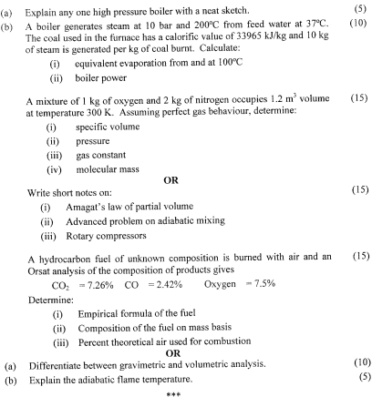
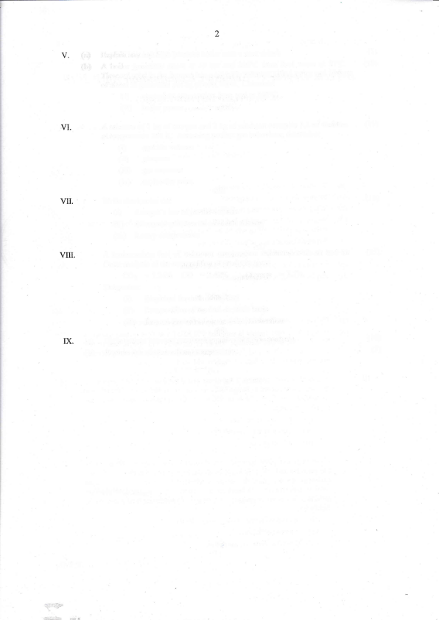
OR
Write short notes on:
(i) Amagat's law of _{Partial} volume
(ii) Advanced problem on adiabatic mixing
(iii) Rotary compressors
A hydrocarbon fuel of unknown composition is burned with air and an Orsat analysis of the composition of products gives
COz:7.260/o CO =2.42Yo OxYgen:7,5%
Determine:
(i) Empirical formula of the fuel
(ii) Composition of the fuel on mass basis
(iii) Percent theoretical air used for combustion
OR
(a) Differentiate between gravimetric and volumetric analysis' (b) Explain the adiabatic flame temperature.
*16*
(1s) (1s)
( 10) (5)

